# Debugging RL Programs

## PDB Introduction

### Overview

The objective of this research is to build a tool that allows the visualization of the behavior of a reinforcement learning agent and facilitates its debugging. Additionally, it is intended to understand the behavior of the RL agent during the training process, to help developers identify the main challenges in the correct operation of RL programs. The research has been carried out since January 2024 and will end in December 2024.

In this sense, you will use usual debugger interfaces to try to solve a Reinforcement Learning program.

### Requirements

You must have python installed, in which the main [PDB (Python Debugger)](https://docs.python.org/3/library/pdb.html#debugger-commands) is already installed

### PDB Commands

PDB lets you navigate through the code, the following list of commands will help you get started.

|  |  |
| --- | --- |
| **Command** | **Description** |
| p | Print the value of an expression. |
| pp | Pretty-print the value of an expression. |
| n | Continue execution until the next line in the current function is reached or it returns. |
| s | Execute the current line and stop at the first possible occasion (either in a function that is called or in the current function). |
| c | Continue execution and only stop when a breakpoint is encountered. |
| args | To see the values of the function running right now. |
| unt | Continue execution until the line with a number greater than the current one is reached. With a line number argument, continue execution until a line with a number greater or equal to that is reached. |
| b | With no arguments, list all breaks. With a line number argument, set a breakpoint at this line in the current file. |
| w | Print a stack trace, with the most recent frame at the bottom. An arrow indicates the current frame, which determines the context of most commands. |
| d | Move the current frame count (default one) levels down in the stack trace (to a newer frame). |
| help | See a list of available commands. |
| q | Quit the debugger and exit. |

## Tasks Description

### The idea for every task is for you to find as many bugs as you can using PDB or VSCode debugger in each of the RL programs. For each task it is expected that you find the main bug hidden in the code. You are supposed to complete the following [form](https://forms.office.com/Pages/ResponsePage.aspx?id=fAS9-kj_KkmLu4-YufucyiW2xLqNTk9Fo4Erde6kdm1UQVlVQU05TFlSWklNWjNXTzg3NFdUR1RPMi4u) with that information. Good Luck!

In [this link](https://github.com/larodriguez22/Flik_Experiments) you will find the experiments to be run for these tasks. Feel free to take a look and download them.

### Task 0: Example

In this task I will show you how to identify a bug using PDB. This is a basic example with an idea on what you are supposed to do. In this example we are using the division algorithm to divide two numbers. But we are missing something, we are not handling all the possible errors. If we run the following code it will work.

def long_division(dividend, divisor):

quotient = 0

remainder = abs(dividend)

divisor = abs(divisor)

while remainder >= divisor:

remainder -= divisor

quotient += 1

if (dividend < 0) != (divisor < 0):

quotient = -quotient

return quotient, remainder

if __name__ == "__main__":

dividend = 17

divisor = 5

quotient, remainder = long_division(dividend, divisor)

print(f"Quotient: {quotient}")

print(f"Remainder: {remainder}")

Now, let’s consider a case in which a developer wants to execute the following division:

long_division(15, 0)

This will generate an error. We can use PDB to run different examples of this code, to change the variables and to see why an error is happening, for example, we can go to line 23, which is going to have an error.

You can run:

python -m pdb task0.py

Then we can run s, to get into the method. And see in real time the execution of the variables. At some point in the execution, we realized that for this case it is not working properly with our method. We are not handling the division by 0. Once we have realized the error, we can change the code and add the following exception:

# Handling division by zero

if divisor == 0:

raise ZeroDivisionError("Cannot divide by zero")

Now, it is your turn to find the bugs in these other tasks.

### Task 1: GridWorld

The idea of this task is for you to figure out what is happening and what is the wrong behavior happening on this Reinforcement Learning program. The idea is for you to identify bugs on it. The gridworld environment consists of a nXn (10 X 10 in our example) rectangular board/grid, in which each tile (i,j) represents a specific state of the board. Tiles in the board may be walls, which agents cannot cross. Additionally, there are special exit tiles that give a positive or negative reward to agents, as shown in the following image. All tile types are unknown to the agent that moves from a given starting point in the board, searching for the goal state (example: exit states with positive reward of 1). The agent moves from state to state, avoiding obstacles and incorrect exit states (which give a reward of -1 when used to exit). For 25 episodes, the result should look like:  
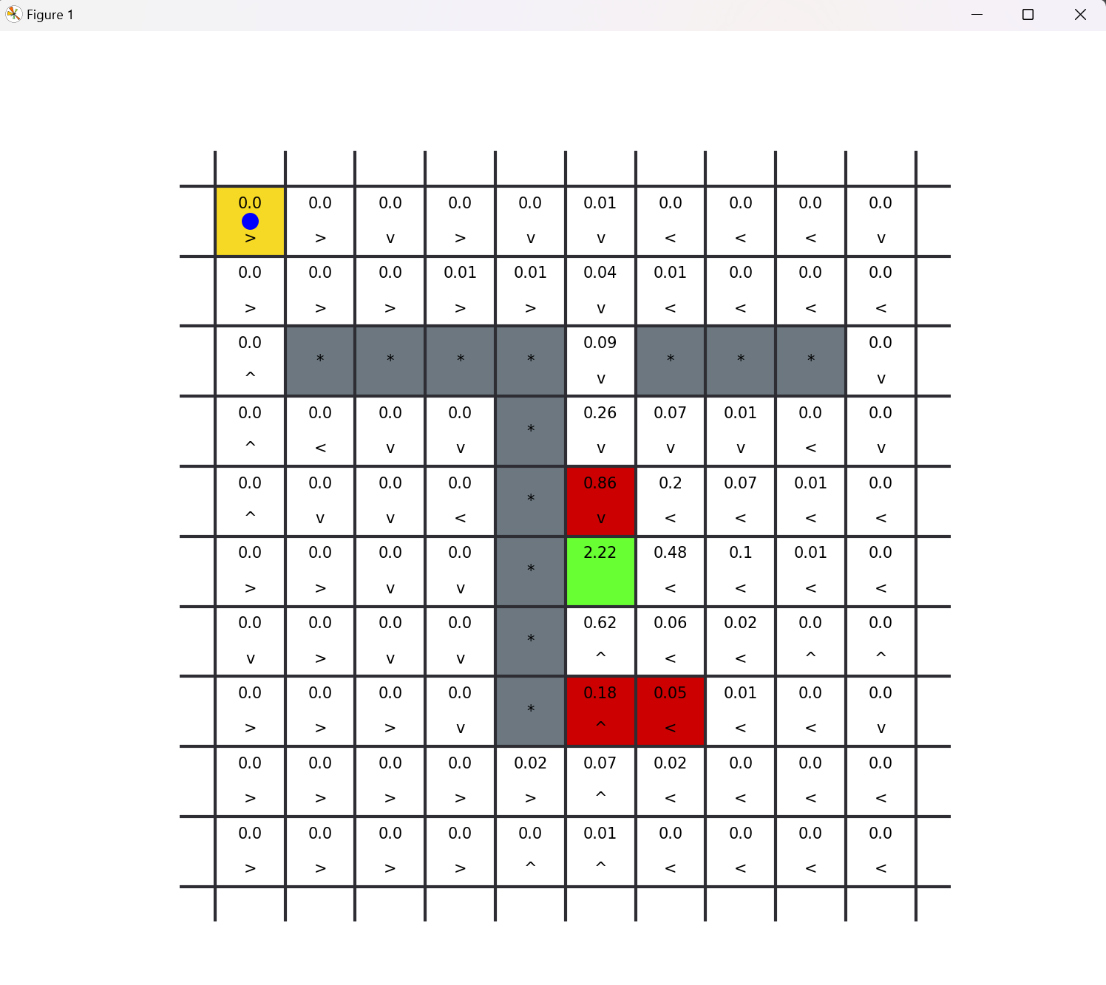

Note that the agent is learning so the values are being propagated on the Q-table.

You can also run the gridworld experiment using the following command:

python3 -m pdb .\gridworld\gridworld.py

### Task 2: Rooms

The four rooms maze environment consists of a 13 X 13 board/grid divided in 4 sections, with walls between them, and a door opening to go from one room to another, as shown in the figure above. The agent's objective in this environment is to exit through the upper-left room (the green square) in the fewest possible steps. Reaching the exit state gives a reward of 1, and no other action gives a reward to the agent. In each episode the agent starts from any valid position in the grid, for example, the yellow square in the bottom-right room in the figure. For 25 episodes, the results should look like:

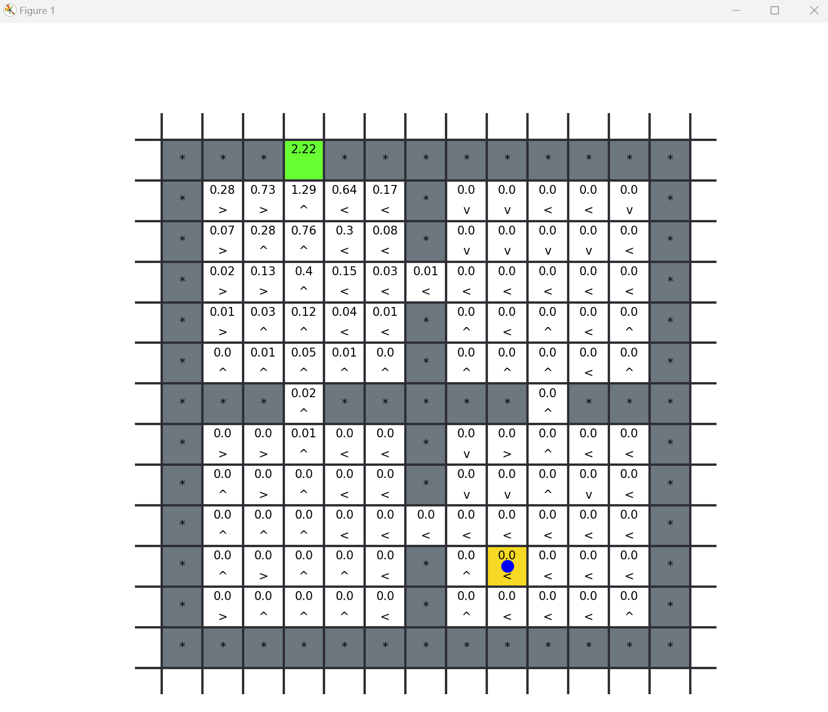

Note the influence of the learning rate. You can also run the rooms experiment using the following command:

python3 -m pdb .\rooms\rooms.py

### Task 2: Driving Assistant

In this example the agent learns to drive on a two-lane road, on the driving lane, at the speed limit, and overtaking slow traffic ahead. The idea of this task is that the agent goes as fast as possible on the road. In the road there are only two lanes, and there are other cars that the agent must pass without crashing on them. The possible actions for the agent are: straight, slow_down, speed_up, steer_left, steer_right. The following is the visual interface of this environment.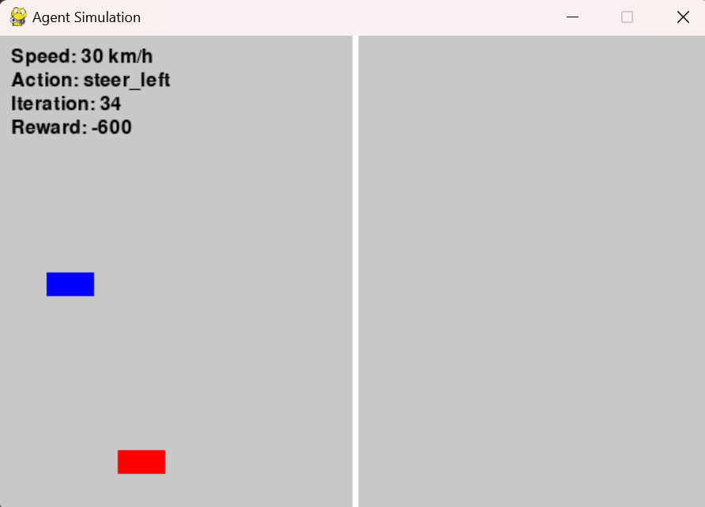

Note that we want the agent to learn how to drive at the maximum velocity allowed, we don’t want the agent to stop, or to crash.

You can also run the rooms experiment using the following command:

python3 -m pdb .\cars\environment.py